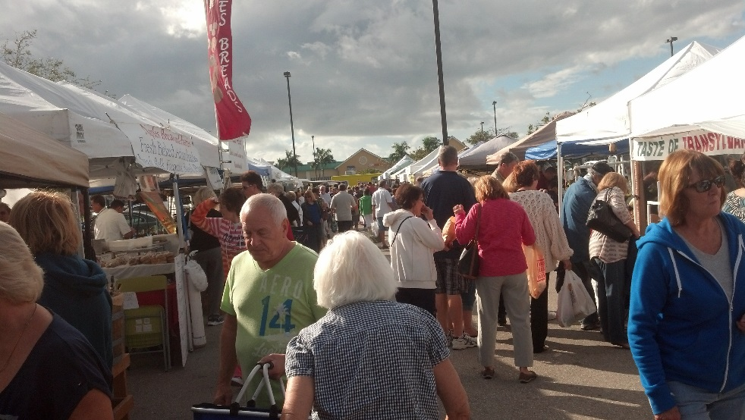

Promote Your Business at
The Surfside Sunset Market
Every Tuesday 2p-7p

This vibrant market is in its 4th year and is a local favorite with both local residents and visitors alike. With an average of 2000 visitors each Tuesday, the market is a great way to expose your business in a great event at a great price!

The Surfside Sunset Market offers 2 ways that your business can participate.

Weekly Space* 10 x 10 Space-based on availability $100/chamber members | $150/non chamber members Surfside Sunset Market.
*No Real Estate Businesses

Market Sponsor $2000 Sponsorship Includes:
Guaranteed Exclusive10 x 10 Space every Tuesday, October 20, 2015-April 26, 2016
Logo on all media: print, web, social, TV and promotional items.

For more information contact Claudia St Onge, Farmers Market Director
239-549-6900 x 101 (or) cso@capecoralchamber.com

SPONSORSHIP APPLICATION

Total amount due for sponsorship: $2000
Please make sure all checks are make out to: Chamber of Commerce of Cape Coral
Payment for all sponsorships is due no later than 1 week before event.
All logos must be submitted with signed sponsorship application.

Company Name
The Paradise Team @ Sellstate Achievers Realty

Contact Name Contact Title
Bonnie L Miller PA & Robert Logsdon

Company Address (including city, state, zip)
1500 Royal Palm Sq Blvd Ste 101 Ft Myers, FL 33919

Phone Number Email Address Fax Number
239-229-1339 (Bonnie) 239-745-5421
bonnie@theparadiseteam.com & bob@theparadiseteam.com

Payment Type: (please check one) ΞCheck Cash Credit Card Invoiced

_____________________________________________ ______________ __________ _____________
Card Number Expiration Date CVV Code Zip Code
______________ ___________________________ _________________________ _____________
Type of Card Name on card Authorized Signature Date

Send completed form to: CSO@capecoralchamber.com, fax to: 239-549-9609 or mail to:
2051 Cape Coral Parkway E, Cape Coral, Florida 33904 ATTN: Cape Coral Farmers Market
Contact Claudia at (239) 549-6900 x101 for additional details
